**COMMUNITY FIRST WEEK**

Idaho First Bank wants to give back to our communities through our time, talent, and treasure. This begins with educating our team members about nonprofits and providing opportunities to engage in an organization that aligns with their personal giving.

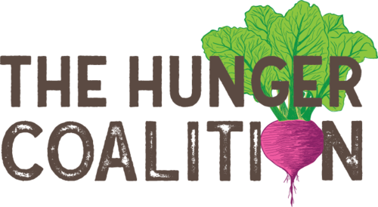

**Ketchum Branch**

Our Ketchum team will be volunteering their time with The Hunger Coalition. They are an organization helping to build a healthy community through access to good food and addressing the root causes of insecurity in collaboration with key partners.  To learn more about The Hunger Coalition, visit their website here: [https://thehungercoalition.org](https://nam02.safelinks.protection.outlook.com/?url=https%3A%2F%2Fthehungercoalition.org%2F&data=02%7C01%7Caperkins%40idahofirstbank.com%7Ca89078ed0a044fe24d1b08d8569a17c2%7C83518ee0b397437096a23d78ccc5b155%7C0%7C0%7C637354567153913347&sdata=zwKTL7cMffzQaKjUFF380QRpkekj0g7DQLYX67uJfWE%3D&reserved=0)

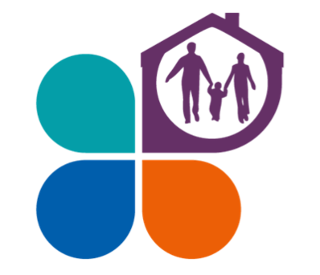

**Nampa Branch**

 Our Nampa team will be volunteering their time with Hope's Door/ Advocates Against Family Violence. AAFV works to eliminate violence in families and homes by empowering individuals to make positive life choices through advocacy, support, education, affordable housing, awareness, and community involvement. To learn  more about Hope's Door AAFV, visit their website here: [https://www.aafvhope.org/about-us](https://nam02.safelinks.protection.outlook.com/?url=https%3A%2F%2Fwww.aafvhope.org%2Fabout-us&data=02%7C01%7Caperkins%40idahofirstbank.com%7Ca89078ed0a044fe24d1b08d8569a17c2%7C83518ee0b397437096a23d78ccc5b155%7C0%7C0%7C637354567153923341&sdata=GW5rpDyg6qe8s9z7fzVDOzzwtklb%2BzTcLg%2B9FY7z84I%3D&reserved=0)

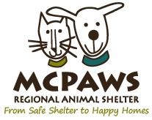

**McCall Branch**

 Our McCall team will be volunteering their time with McPaws and the. MCPAWS is a Regional Animal Shelter providing safe shelter for abandoned, lost, and surrendered dogs and cats; to find loving homes for all adoptable animals. To learn more about McPaws, visit their website here: [https://mcpaws.org](https://nam02.safelinks.protection.outlook.com/?url=https%3A%2F%2Fmcpaws.org%2F&data=02%7C01%7Caperkins%40idahofirstbank.com%7Ca89078ed0a044fe24d1b08d8569a17c2%7C83518ee0b397437096a23d78ccc5b155%7C0%7C0%7C637354567153923341&sdata=hVJC3CELtamXku1pABebnHh3Xk2xIy4%2BP2nLSOfu1SI%3D&reserved=0)

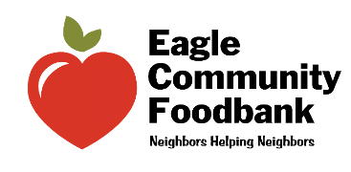

**Eagle Branch**

 Our Eagle team will be volunteering their time with the Eagle Food Bank. The Eagle Community Foodbank is a 501(c)(3) nonprofit public charity which provides food assistance to 50 to 75 families per month or 150-200 individuals in Eagle and Star. To learn more about the Eagle Food Bank, visit their website here: [http://www.eaglefoodbank.com](https://nam02.safelinks.protection.outlook.com/?url=http%3A%2F%2Fwww.eaglefoodbank.com%2F&data=02%7C01%7Caperkins%40idahofirstbank.com%7Ca89078ed0a044fe24d1b08d8569a17c2%7C83518ee0b397437096a23d78ccc5b155%7C0%7C0%7C637354567153933335&sdata=ulwg5%2BAF26z7yd%2FfLtFyOXDrQZ%2F%2FeODIv%2BGrX1c%2F7mM%3D&reserved=0)

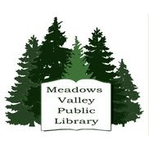

**New Meadows Branch**

 Our New Meadows team will be volunteering their time by washing the windows of the library. The New Meadows library regularly rounds up new books, audios & movies, helps out with the children’s summer reading program, and helps to provide the community with travelogue & speaker programs. To learn more about the library and how you can volunteer, visit their website here: [http://meadowsvalley.lili.org](https://nam02.safelinks.protection.outlook.com/?url=http%3A%2F%2Fmeadowsvalley.lili.org%2F&data=02%7C01%7Caperkins%40idahofirstbank.com%7Ca89078ed0a044fe24d1b08d8569a17c2%7C83518ee0b397437096a23d78ccc5b155%7C0%7C0%7C637354567153933335&sdata=XJr%2FPV1zI2oRUWeLlGmWWI464hxw7YRiXIMiFar3Vbk%3D&reserved=0)

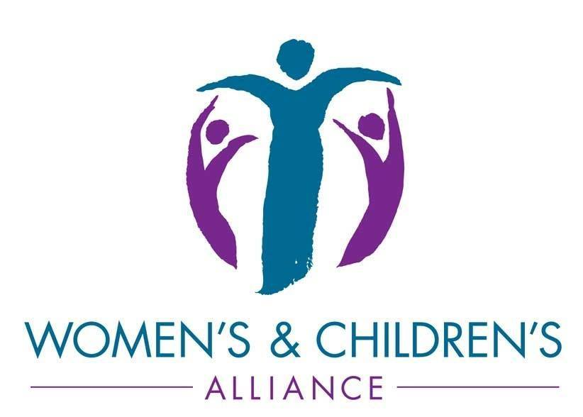  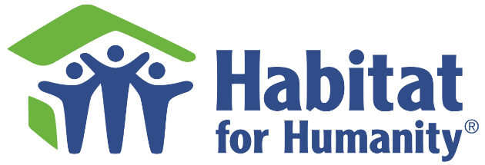    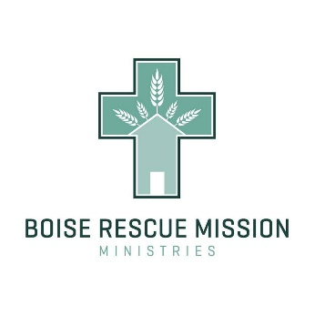

**Boise Branch**

Our Boise team will be splitting up into (3) groups to volunteer at the Habitat for Humanity, Boise Rescue Mission and the Women and Children Alliance. Habitat works toward our vision by building strength, stability and self-reliance in partnership with families in need of decent and affordable housing.The Boise Rescue Mission Ministries reaches out to the community by teaching the Word of God and providing food, shelter, clothing and opportunities to recover from homelessness for men, women, and children in need. Lastly, the Women and Children Alliance provide Safety to domestic abuse and sexual assault victims through our two [24-hour crisis hotlines](https://nam02.safelinks.protection.outlook.com/?url=http%3A%2F%2Fwww.wcaboise.org%2F24-hour-crisis-hotline%2F&data=02%7C01%7Caperkins%40idahofirstbank.com%7Ca89078ed0a044fe24d1b08d8569a17c2%7C83518ee0b397437096a23d78ccc5b155%7C0%7C0%7C637354567153943334&sdata=cZqMPViPfNgfsjXk7axPgEBsk8SIeUdLAXMcP5YieaI%3D&reserved=0), our domestic abuse shelter, safety planning assistance, and court advocacy. To learn more about any of these organizations, visit their websites: <http://www.wcaboise.org>, <https://www.habitat.org>, or <https://boiserm.org>.